**Brooklyn torah gazette**

**For parshas Bereishis 5782**

Volume 6, Issue 2 (Whole Number 257) 26 Tishrei 5782/ October 2, 2021

**Printed L’illuy nishmas Nechama bas R’ Noach, a”h**

For a free subscription, please forward your request to [***keren18@juno.com***](mailto:keren18@juno.com)

**How a Rock Song Started**

**Me on My Journey**

**By** [**Linda Hirschel**](https://www.chabad.org/search/keyword_cdo/kid/22526/jewish/Hirschel-Linda.htm)

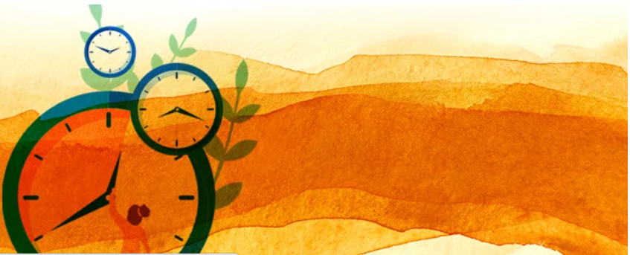

When I was 6 years old, a rock group called “The Byrds” released the song “Turn! Turn! Turn!” Later, in high school and college, I loved this song; I am sure that anyone who grew up in the 1960s responds to that classic guitar and percussion intro. The words are based on Kohelet, Ecclesiastes, which some communities have the custom to read on Sukkot.

In high school, we used to discuss various philosophers. My personal favorite was Albert Camus. He spoke about the myth of Sisyphus—the tragic Greek figure who eternally pushes a huge rock up the hill and then watches it roll back down again, pushing it up and watching it roll back down repeatedly. For Camus, this is life.

Camus believed that life was absurd, that there was no real purpose to it. He found comfort in the effort, in the here and now of rolling the rock back up the hill. He found comfort in the clarity of knowing that everything is absurd, but that we can still find beauty and pleasure in the moment. Camus tells us, “One must imagine Sisyphus happy.”



**Albert Camus**

I was fairly satisfied with that philosophy. After all, I had a pleasant life with a pleasant family. There didn’t seem to be much purpose in it, but I tried to make rolling that rock up the hill satisfying with a certain cosmic clarity—that even though everything is absurd, we can derive satisfaction by experiencing each moment mindfully.

The song by the Byrds led me to read [Kohelet](https://www.chabad.org/library/bible_cdo/aid/15779/jewish/Ecclesiastes.htm), written by King Solomon, in English. Even King Solomon says that everything is futile: “For what has a man of all his toil and his stress in which he labors beneath the sun? For all his days are painful, and his business is a vexation; even at night his mind has no rest. This too is futility!”

I thought King Solomon was right! Everything is futile; there is no real purpose to our endeavors. He understood, as Camus says, that everything is truly absurd. And Kohelet continues: “I therefore observed that there is nothing better for man than to be happy in what he is doing, for that is his lot.” Just what Camus said, I thought, only King Solomon said it 3,000 years before! Now that was exciting.

The irony is, I never finished [Ecclesiastes](https://www.chabad.org/library/bible_cdo/aid/15779/jewish/Ecclesiastes.htm). I stopped before I reached the end. And yet, the final words are the guidebook to negotiating the world in which we live. The end of the book gives us instruction on how to deal with the seeming futility of life:

*The sum of the matter, when all has been considered:*

*Fear G‑d and keep His commandments,*

*For that is man’s whole duty.*

So that is the entirety of man! Human beings have a spiritual essence, and this is where they make order out of a meaningless world. Not by being distracted by the pulls of this world but by nourishing their soul to become closer to [G‑d](https://www.chabad.org/library/article_cdo/aid/433240/jewish/God.htm). Of course, a Jew does not run away from the world. He raises up the material world; otherwise, the material world is just the rock falling down, again and again.

Eventually, I found myself in a seminary in Jerusalem, studying Torah. I began keeping [Torah](https://www.chabad.org/library/article_cdo/aid/1426382/jewish/Torah.htm) and mitzvot. I got married and raised observant Jewish children and now grandchildren. It was not until many years later that I came back to Ecclesiastes.

*To everything there is a time,*says Kohelet*.*

*... there is a time for everything under heaven.*

This statement is so comforting. Why didn’t this or that happen at a different time? For example, a person might say, “Why didn’t I get married younger? Why did I have to wait so long for my first child?” And yet, it all comes at the right time for each person. We have strong faith that all that happens to us, including when it happens, is for our own good. *Emunah* means faithfulness to the belief that everything is from G‑d.

This does not take away from the pain and sorrow of life, but still, everything is meant to happen at the right time. To me, this is very reassuring.

... *a time to embrace ... a time to keep away from embracing.*

Even our relationship with G‑d is like that; there are times when we feel G‑d’s proximity and times when we feel far away. In actuality, that’s only our perception. G‑d is always available. We get comfort by crying out to G‑d, even in our most painful moments.

And so, I thank the Byrds for their introduction to a lesson in Kohelet. After all, it’s where I started my journey from a secular, college-educated Jew to a full-fledged Torah-observant Jew, complete with Shabbat and kashrut: Turn, turn, and then, I turned some more!

All at the right time.



Linda Hirschel is a freelance writer and CBT therapist living in Israel. She is a mother and a grandmother, and she enjoys making soups and growing flowers.

*Reprinted from the Parshas Bereishis 5782 email of Chabad.Org Magazine.*

**Parshas Bereishis:**

**The Torah is a Law Book –**

**Not a Story Book**

**By Rabbi Bentzion Shafier**

**Founder of TheSmuz.com**



“*In the beginning, G-d created the heavens and earth*.” — Bereishis 1:1

The Torah begins with these words, telling us the order of Creation. Rashi points out that the Torah should have begun with the first mitzvah and continued with a list all of the positive and negative commandments. A detailed description of the order of Creation should not have been a part of the Torah.

Rashi answers that the Torah began by telling us that HASHEM created everything so that we would have an answer to the claim that the nations would form against us. If the gentile peoples would say to us, “You are thieves. You stole the land that belongs to the seven nations,” our answer is, “It says in the Torah that HASHEM created the heavens and the earth. It is His world. He created it, and He gave it to whom he saw fit.”

The Siftei Chachamim explains that Rashi’s question cuts to the core purpose of the Torah. The Torah is the guidebook for life, a compilation of the laws and principles that govern our actions. Ultimately, it is a book of laws. Therefore, all of the stories that are told throughout Bereishis — from Adom, Noach, and on through the Avos — simply don’t belong there.

Granted they contain valuable lessons to teach us, but those lessons could have been written in a book on the level of the Navi’im, not in the Torah itself. The reason they became part of the Torah itself was that since HASHEM began with chronicling the acts of Creation, it was appropriate to maintain that style, so the Torah continued with the various stories as they occurred.

Essentially, Rashi’s question is that the very nature of the Torah was changed from a law book to a history book. Why make that change? Rashi answers that it was all changed so that if the gentiles say, “You are thieves,” we could simply respond, “Read the Bible. HASHEM created the heavens and earth and gave it to us.”

**The Torah Was Written Exclusively for Yisroel**

There are two significant problems with this Rashi:

1. The Torah is the exclusive property of the Jews. It was written for the Jews, and it is unique to the Jews. It wasn’t written for the gentiles. We cannot assume that the gentiles will read the Torah, much less abide by it. More than that, they have no right to read the Torah; it is the private heritage of the Jewish nation. So how can Rashi say that this is the answer to the goyim when the Torah isn’t in their purview?

2. If the sole reason HASHEM began with Creation was so that the gentiles won’t say that we stole their land, then it seems, if it could be, that HASHEM failed. The single most repeated claim that the world has against the Jews today is exactly that: we **stole** their land. We took away the Palestinian homeland. We have no right to be there. If the entire reason that HASHEM changed the Torah was to answer the gentiles, it doesn’t seem to have succeeded. So what does Rashi mean, “It is to answer the gentiles”?

The answer to these questions is contained in Rashi’s use of the posuk:כח מעשיו הגיד לעמו “Hashem told **His nation** of His power.” Like the rest of the Torah, this lesson is not for the gentiles; it is for us. If the gentile nations accuse us of stealing their land, we need to have the answer, not for them, but so we can answer ourselves. It is a foregone conclusion that the gentiles won’t listen to the Torah. The issue is us. Will we feel justified and correct or will we feel like we have stolen their land? This issue is so significant that HASHEM changed the very nature of the Torah . . . to let us know we are not thieves.

**A Person’s Thoughts Define Him**

If we take this concept to its logical conclusion, we see a tremendous insight into human nature. Rashi is telling us that all of the lessons that we learn from the Avos — the concepts of mussar, self-improvement, and perfection of our middos — are very important, but they could have been put in a separate book.

However, the issue of not viewing ourselves as thieves is so fundamental that it merits changing the entire Torah. This is because the way a person views himself is what he becomes. If a person views himself as a thief, he will live up to that image. If the Jewish nation viewed themselves as crooks, dishonestly living in someone else’s land, they could never have become the chosen nation. Their tainted view of themselves would have greatly limited their ability to become great people, and that is so significant that it is worth changing the entire Torah.

This concept has a specific message to us. Some people are concerned about stealing because “What will the gentiles think about us?” While that may be a valid concern, there is a much bigger issue at stake: how will I view myself? If I act as thief, I am a thief. That action defines me, and creates the image that I hold about myself. That damage can be far greater than the single act of stealing.

There is also a larger lesson to learn from this Rashi. One of the characteristics that all successful people possess is a powerful sense of self-worth. To reach greatness, a person must believe in himself. He must trust in his inherent worth and his ability to succeed. If this key component is missing, all the talent in the world will not help because he will not have the drive to reach for the heights he is capable of. This concept is so intrinsic to greatness that HASHEM changed the very nature of the Torah, all to keep our sense of dignity and worthiness intact.

*Reprinted from the current website of TheShmuz.com*

**Rabbi Berel Wein on**

**Parshat Bereshith 5782**

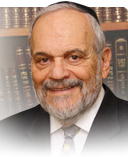

The Torah in this week's opening reading begins with a description of the generations of human beings – the narrative of human life and civilization. It points out that originally there was a choice of whether to live in paradise in the Garden of Eden, or to attempt to reach for hoped-for human greatness and accomplishment through knowledge, intellect, and the human spirit.

That choice, which was made for us and for all the succeeding generations of human beings -the untold billions that have inhabited this planet for millennia, led to our expulsion from Paradise and the Garden of Eden, into a very dangerous and challenging world.

The epic poem of English literature by John Milton who entitled his work "Paradise Lost", shows that since the beginning of time humankind has attempted, somehow, to regain its foothold in that original paradise, but all to no avail. We can well imagine the fright and trauma of our biological ancestors, forced into the world of wild animals, great and fearsome reptiles, and an unforgiving earth that produced thorns and weeds, from which, somehow, by enormous effort, ingenuity and the sweat of their brows, food would have to be toiled for, produced, and then gathered.

The story of humankind until this day is the never-ending quest to be able to feed and sustain itself in all types of harsh environments and demanding situations. It may not be an exaggeration to view all the conflicts and wars that have marked human history until today, as the attempts to gain more land and territory to secure sustenance.

The Germans slaughtered tens of millions of innocent people, to achieve what they call ‘lebenstraum’ – room to live and find sustenance. However, such attempts to gain for oneself by destroying others is not only morally reprehensible but is also self-defeating in practice as well as counterproductive.

But this is only part of the human struggle. The other part, equally important and even more difficult to achieve, is to somehow find the way back to that Paradise, from which the human race was expelled. This search lies at the root of all our dissatisfaction, depression, and emotional turmoil. We know instinctively that we are not in our real homes and that we should be in a better and more spiritual place.

Judaism posits that through the Torah and the fulfillment of its value system, we can gain a foothold on the road that leads us back to paradise and eternity. This road is also strewn with thorns and obstacles. Paradise is not gained by the fainthearted, or by those who seek only leisure and comfort in their lives. In fact, the difficulties that all of us encounter in life are themselves the very tools that will help us regain our footing and direction towards paradise.

This week's reading emphasizes that we were born to struggle, to suffer discomfort and constant challenge, and to live in a tense and dangerous world. Nevertheless, the road to paradise does exist, and each of us is tasked with finding it and negotiating with it to its eternal end.

*Reprinted from the current website of rabbiwein.com*

**The Lesson of the Letter “Beit” And the Second Stage in**

**Approaching G-d’s Wisdom**

**From the Talks of the Lubavitcher Rebbe**

**Rabbi Menachem Mendel Schneerson, Zt”l**

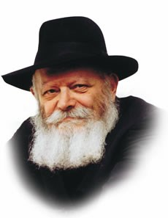

The Torah begins with the word "Bereishit--In the beginning," the first letter of which is the letter beit.

Beit is the second letter of the Hebrew alphabet, yet G-d chose to begin His Torah precisely with this letter. One would think that the Torah would start with the letter alef, as everything in the Torah is arranged in an orderly fashion. Thus, at first glance it would seem more logical for the Torah to have opened with the word "Elokim"--"G-d created in the beginning the heavens and the earth," rather than with "Bereishit."

What are we to learn from the fact that the Torah begins with the letter beit?

Nothing in the Torah is unintentional or accidental. Rather, the specific use of the second letter of the alphabet alludes to the fact that, for the Jew, the actual study of Torah must be the second stage in his approach to G-d's wisdom.

Before learning G-d's Torah, the Jew must prepare himself appropriately. Only after he has done so will his learning be conducted in the proper manner G-d has prescribed.

How is a Jew to prepare himself? By contemplating the special holiness that the Torah contains. A Jew must always remember that G-d gave us His holy Torah for the express purpose of connecting ourselves to Him. Learning G-d's Torah is the means by which we may do so.

If a person does not think about G-d before he studies, he is liable to look upon the Torah as a collection of narratives, a guide to our conduct, or perhaps merely a book which contains great wisdom.

Without the proper preparation, he may forget that the Torah is sacred, and that its main objective is to allow us to connect ourselves with the Giver of the Torah.

To remind himself, the Jew must recite a blessing over the Torah every morning before he commences learning. By saying "Blessed are You L-rd, Who gives the Torah," we place the One Who has given us the Torah foremost in our minds.

Only then do we arrive at the second stage, the stage of actual study, through which we attach ourselves to G-d. And the more Torah we learn, the more connected we are to Him.

Thus the letter beit serves to teach us that the Torah is G-d's Torah, and that the primary purpose of its study is to connect ourselves to Him.

*Reprinted from the 5756/1996 Parshat Breishis edition of L’Chaim Weekly. Adapted for Ma’ayan Chai from the works of the Lubavitcher Rebbe.- Likutei Sichot, vol. 15*

# Rav Avigdor Miller on

# How to be Likeable



**QUESTION: How can a person make himself be liked by the people he meets every day?**

**ANSWER:** So, for that you’ll have to be ready now for a two hour lecture.   
  
 First of all, don’t talk too much.

And secondly, show that you like that person – even though you don’t. It’s a mitzvah to be a good actor and Hakodosh Boruch Hu will reward you for showing that you like that person. Now, if it’s a decent person, try your best to make a hit with him. But if he’s a person of low character, so just be polite, smile, and get rid of him as fast as you can. לך מנגד מאיש כסיל – Go far away from a fool. The reshaim are fools, so don’t waste too much time on them. But if there is any hope, spend some time trying to win him over. But in either case, to everybody you have to be polite.

Now, the next thing, the third thing, is to find something that’s good in that person that you can encourage. If you say some encouraging words he will prize it all his life.

So, I’ve told you so far three things. That’s an installment, maybe for some future lecture. I’ll repeat it. First of all, don’t talk much; listen. Secondly, smile – show that you like the person. Thirdly, try to encourage him in some good thing – in his parnasa, or in his family – whatever it is, try to encourage him.

Now as I said before, in case he’s not a person of good character, so as soon as possible part company with him. The less time you spend with him, the better you are.

You want some more information? Maybe in the future we’ll talk about this topic.

*Reprinted from the September 3, 2021 email of Toras Avigdor (Tape #731.)*

**Cheder in Lublin, Poland (circa 1920s)**

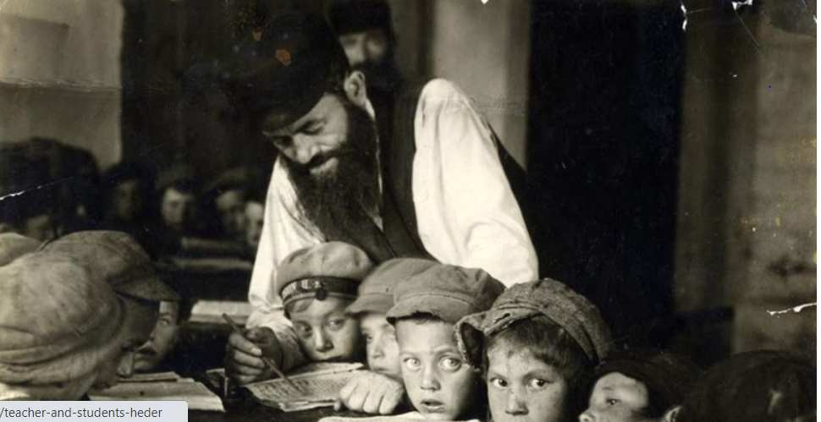

*Photo by Alter Kacyne, hy”d, (killed in a Nazi pogrom in 1941 (1885-1941).*